**DATA MINING ASSIGNMENT**

**AMMANAMANCHI SAI KARTHIK**

**B150310CS**

**10**

**About the dataset:**

buying v-high, high, med, low

maint v-high, high, med, low

doors 2, 3, 4, 5-more

persons 2, 4, more

lug_boot small, med, big

safety low, med, high

The dataset has 6 feature variables and 1 class variable

Number of Instances: 1728 (instances completely cover the attribute space)

Number of Attributes: 6

**1 a. Decision Tree with Gini index as the impurity measure**

**Loading the data**

data_url <- c("https://archive.ics.uci.edu/ml/machine-learning-databases/car/car.data");

download.file(url=data_url,destfile = "car.data");

mydata <- read.csv("car.data",sep=",",header=FALSE)

**Data Slicing**

**Splitting the data into training set and test set**

ind <- sample(2, nrow(mydata), replace=TRUE,prob=c(0.8, 0.2))

train <- mydata[ind==1,]

test <- mydata[ind==2,]

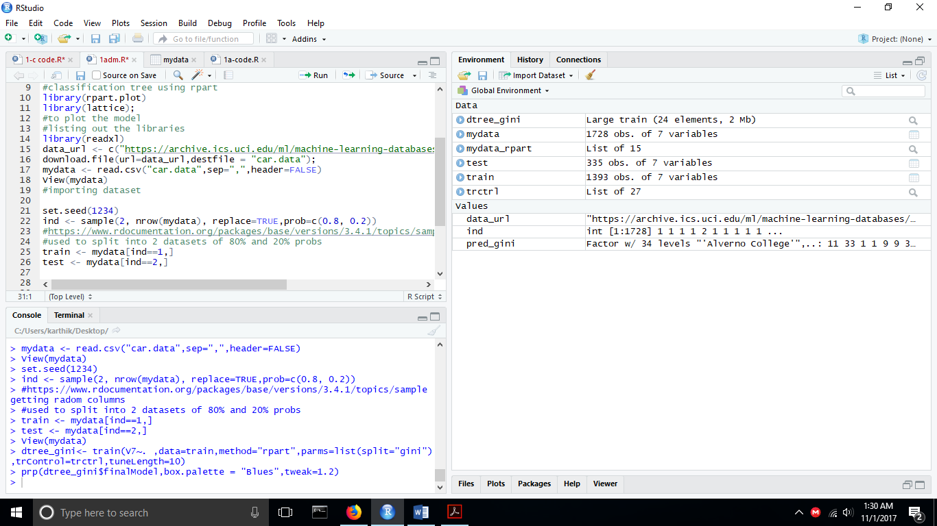

**Training the dataset using the caret library based on decision on gini index on university column**

trctrl <- trainControl(method="repeatedcv",number=10,repeats=3);

set.seed(3333);

dtree_gini<- train(V7 ~. ,data=train,method="rpart",parms=list(split="gini"),trControl=trctrl,tuneLength=10)

**Displaying the dataset**

prp(dtree_gini$finalModel,box.palette = "Blues",tweak=1.2)

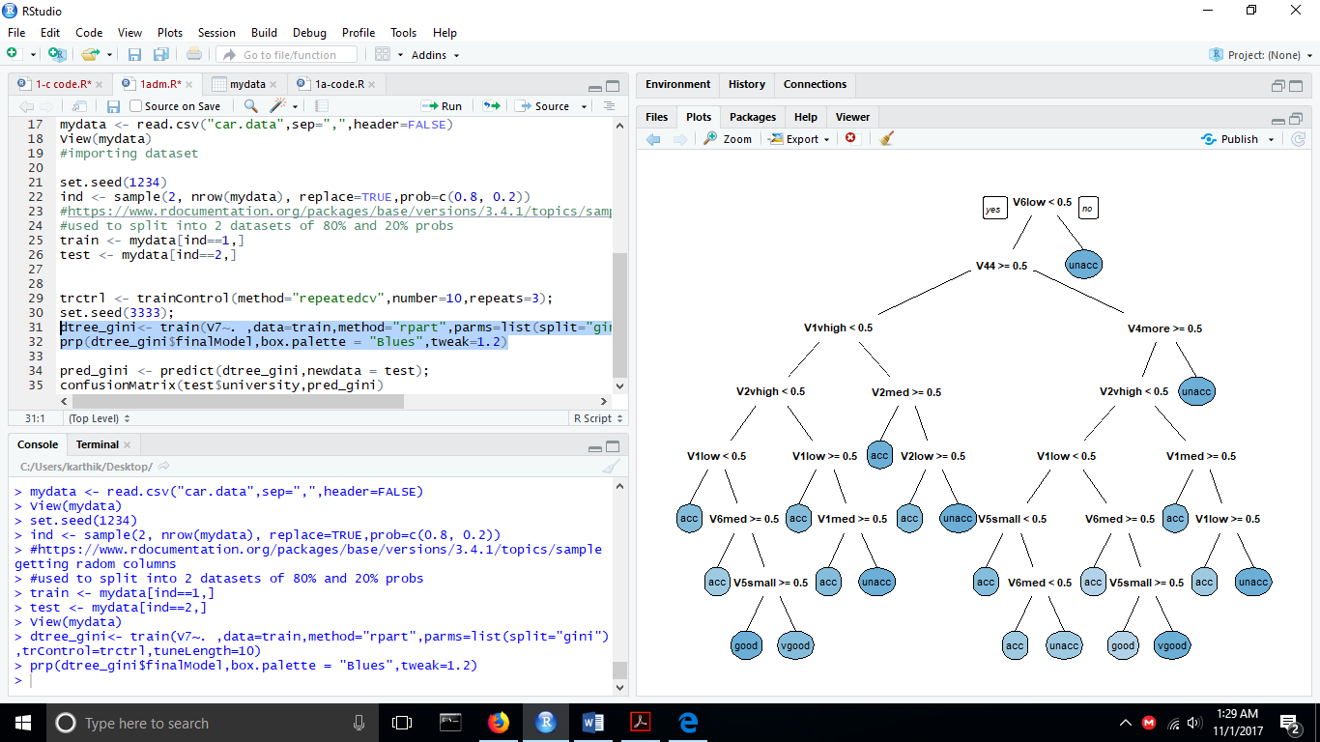

We can check if our dataset contains any missing values using the anyNA(dataset) function

To check the summary of the dataset we can use summary(dataset)

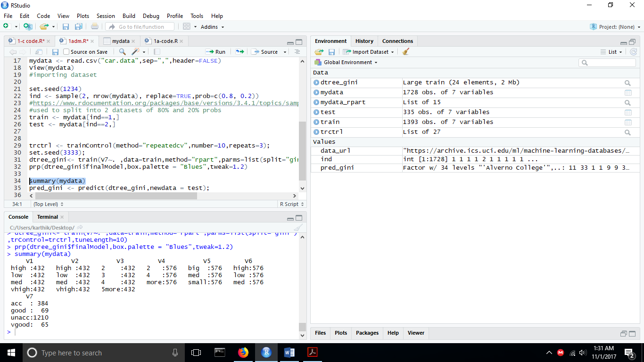

**Prediction**

Our model is trained with a cp of 0.008252427

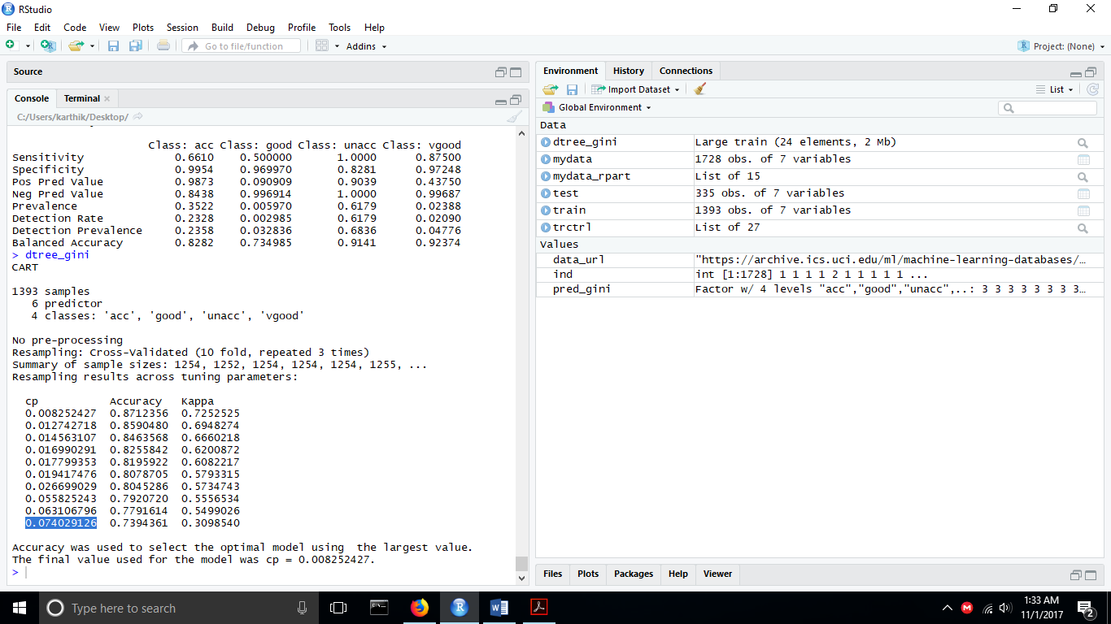

**Confusion Matrix and statistics**

pred_gini <- predict(dtree_gini,newdata = test);

confusionMatrix(test$V7,pred_gini)

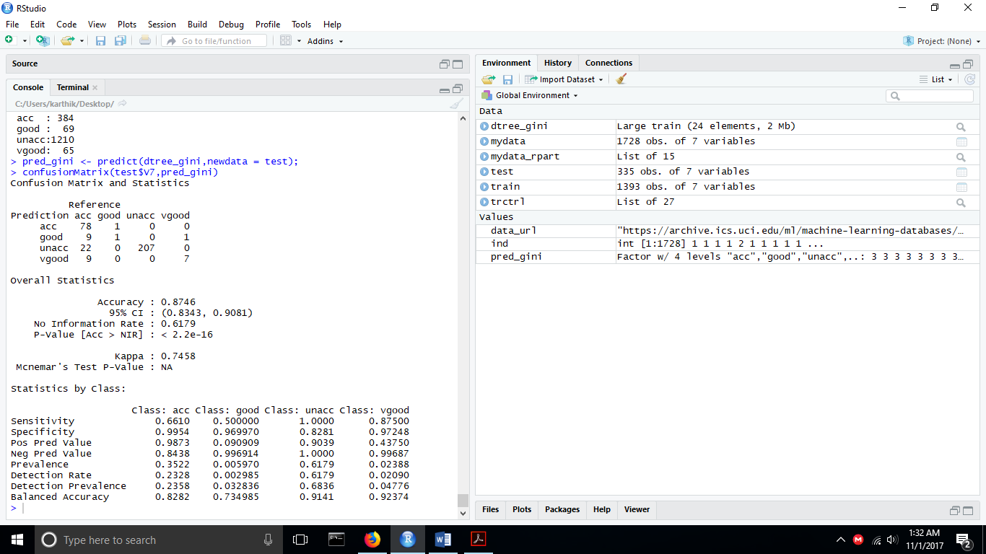

**Accuracy : 87.46%**

The values of fmeasure,recall,precision are as follows:

**Precision, Recall and f- measure**

result<- table(pred_gini,test$V7)

precision <- result[1][1]/(sum(result[1,]));

recall <- result[1][1]/(sum(result[,1]));

f_measure <- 2 * ((precision * recall) / (precision + recall))

precision

recall

f_measure

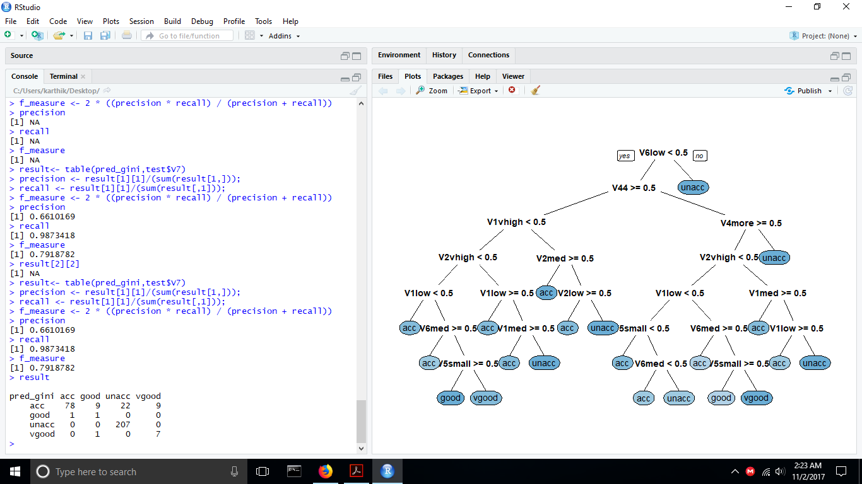

**10 fold cross validation**

set.seed(1234)

mydata<-mydata[sample(nrow(mydata)),]

#Create 10 equally size folds

folds <- cut(seq(1,nrow(mydata)),breaks=10,labels=FALSE)

#Perform 10 fold cross validation

for(i in 1:10){

#Segement your data by fold using the which() function

testIndexes <- which(folds==i,arr.ind=TRUE)

test <- mydata[testIndexes, ]

train <- mydata[-testIndexes, ]

#Use the test and train data partitions however you desire...

}

**We use this code for 10 fold cross validation**

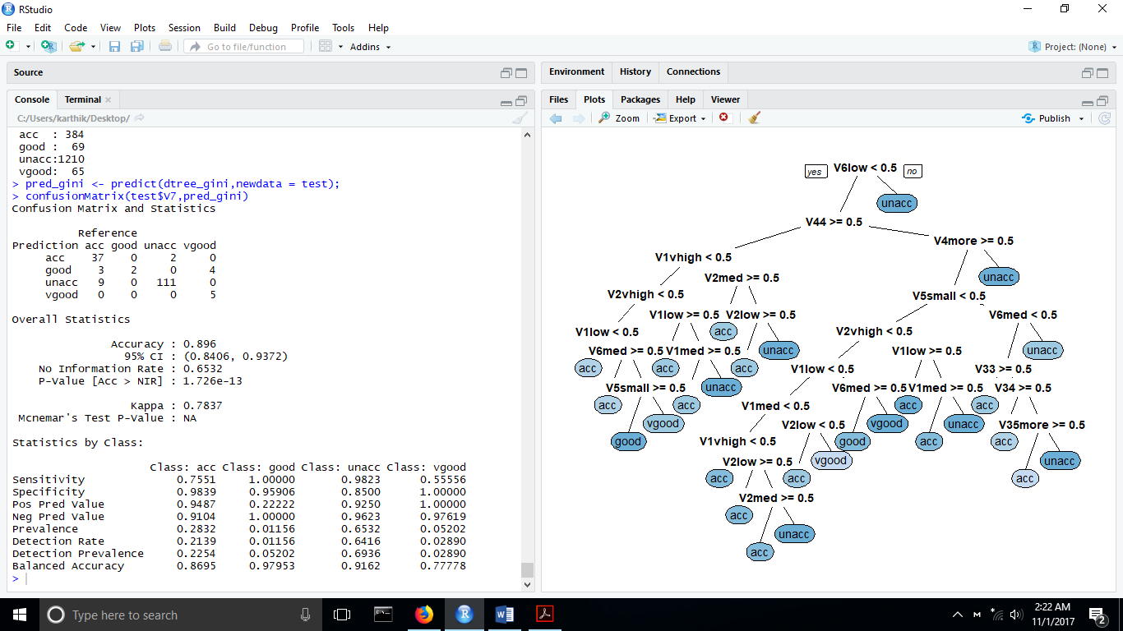

**Now the accuracy is 89.6%**

**This classifier performs better with case 2 i.e 10 fold cross validation**

**ROC Curve**

**Install pROC library before proceeding**

**pred<- predict(dtree_gini,test,type='prob')**

**auc<-auc(test$V7,pred[,2])**

**plot(roc(test$V7,pred[,2]))**

In a ROC curve the true positive rate (Sensitivity) is plotted in function of the false positive rate (Specificity) for different cut-off points of a parameter. Each point on the ROC curve represents a sensitivity/specificity pair corresponding to a particular decision threshold. The area under the ROC curve (AUC) is a measure of how well a parameter can distinguish between two class groups.

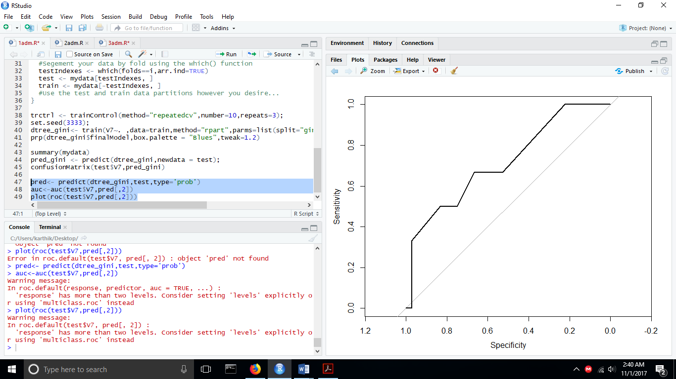

Area under the curve: 0.8621

**1 b. Decision Tree with Entropy as the impurity measure**

**We now simulate the steps in 1 a and change the statement to obtain the impurity measure**

dtree_gini<- train(university ~. ,data=train,method="rpart",parms=list(split="gini"),trControl=trctrl,tuneLength=10)

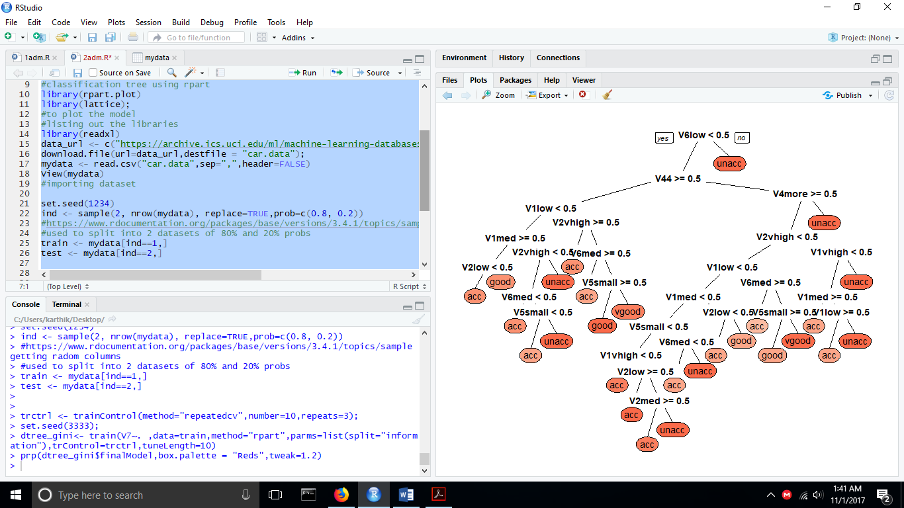

**Confusion matrix and Statistics**

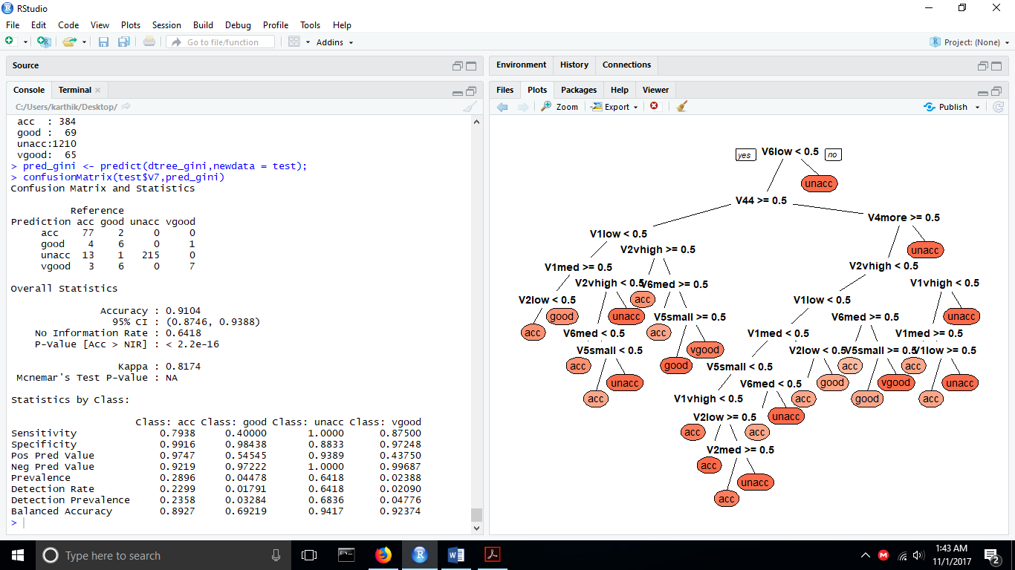

**Accuracy: 91.04%**

Using **10 fold cross validation** similar to 1 a

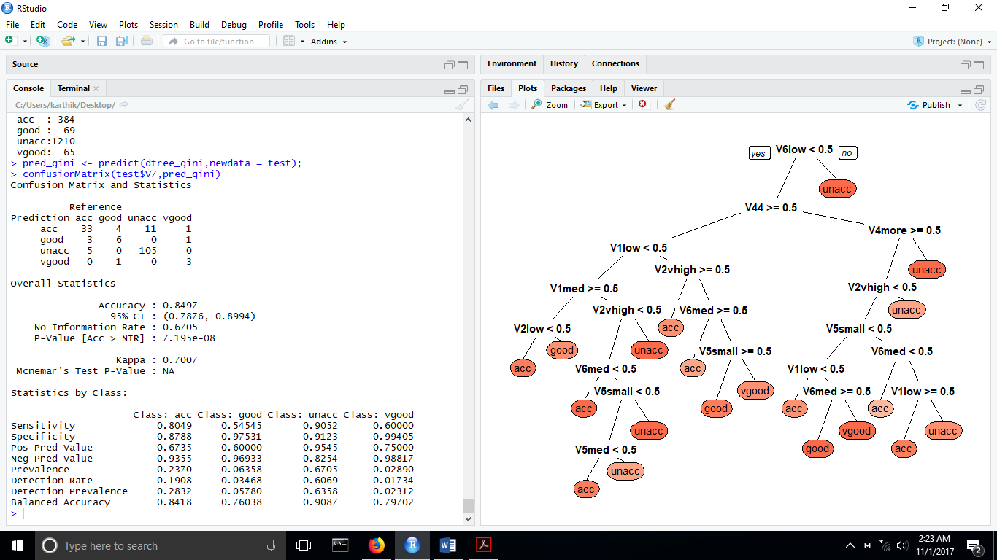

**The accuracy now is 84.97%.**

**This classifier performs better with case 1 i.e random sampling**

**Precision, Recall and f- measure**

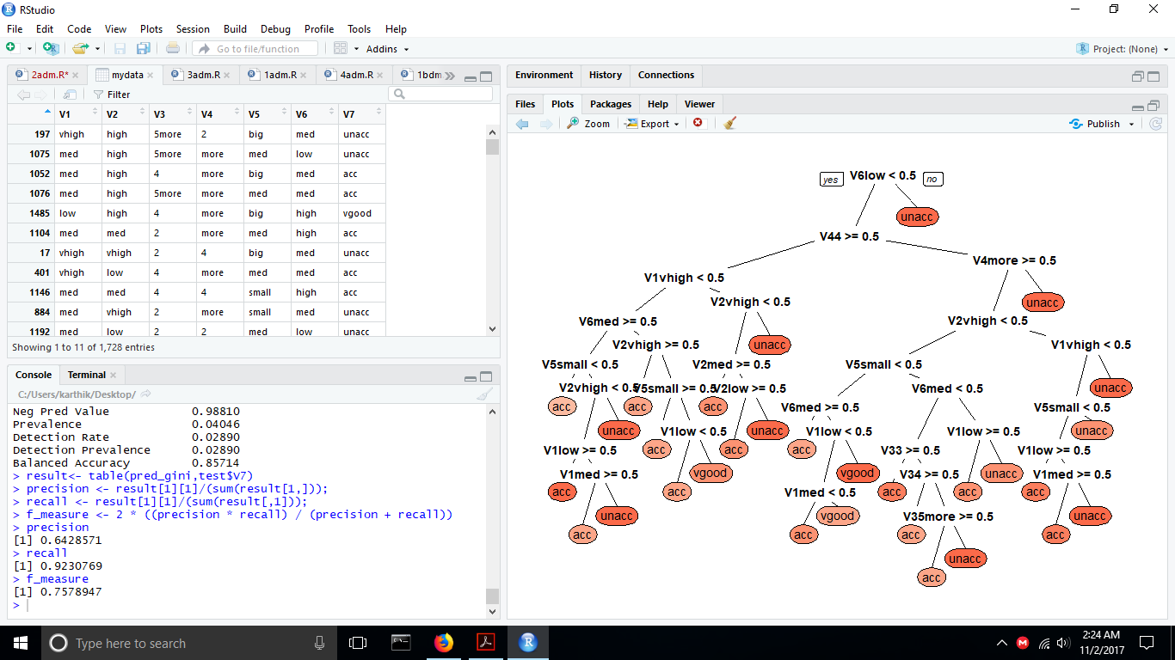

**ROC Curve**

Find the ROC curve similar to 1 a

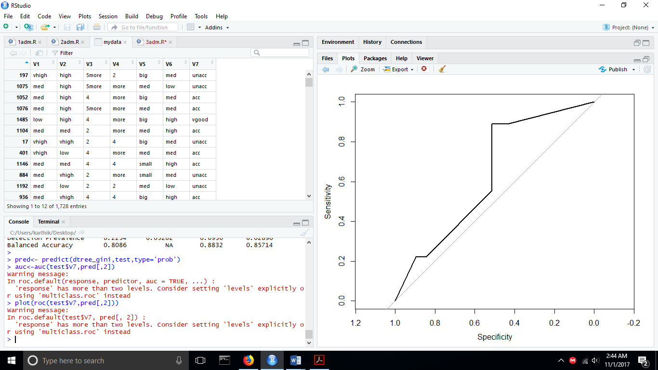

**Area under the curve: 0.8694**

**1 c. Naïve Bayesian Classifier**

We now install and include the libraries rminer and e1071.

naivemodel<-naiveBayes(V7~.,data=train);

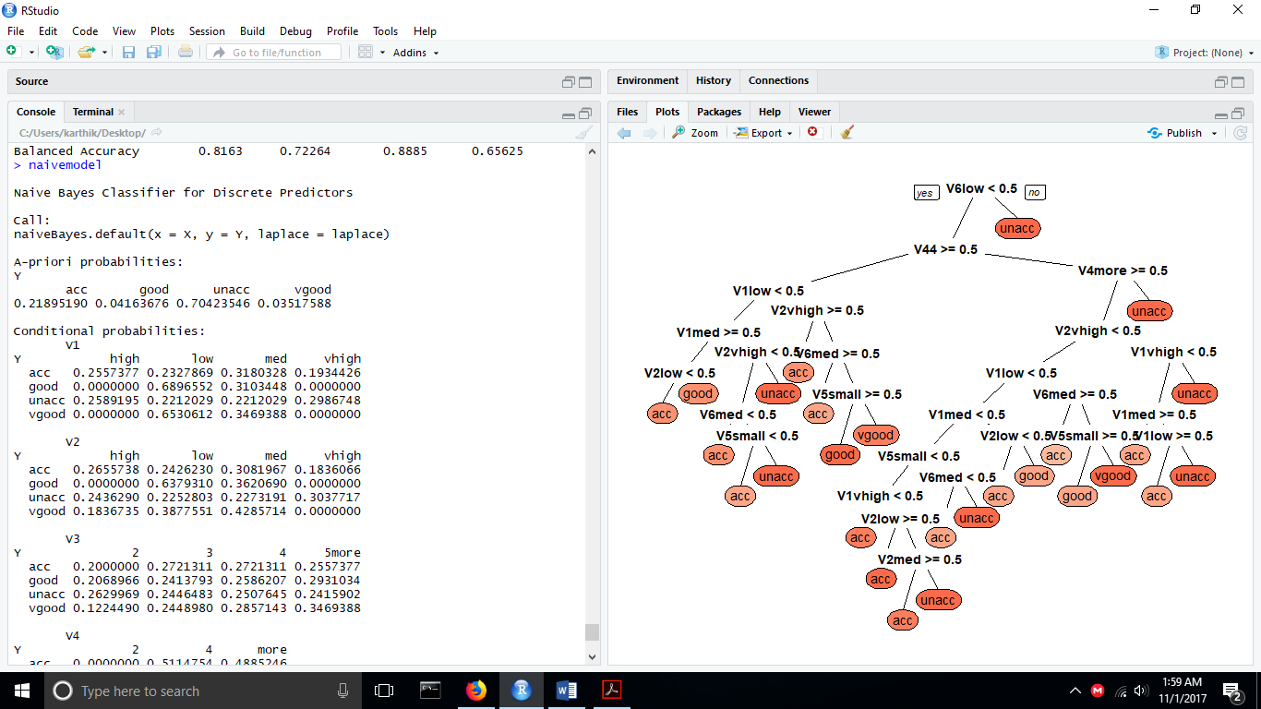

test_pred<-predict(naivemodel,newdata=test);

confusionMatrix(test_pred,test$V7);

Confusion Matrix and statistics:

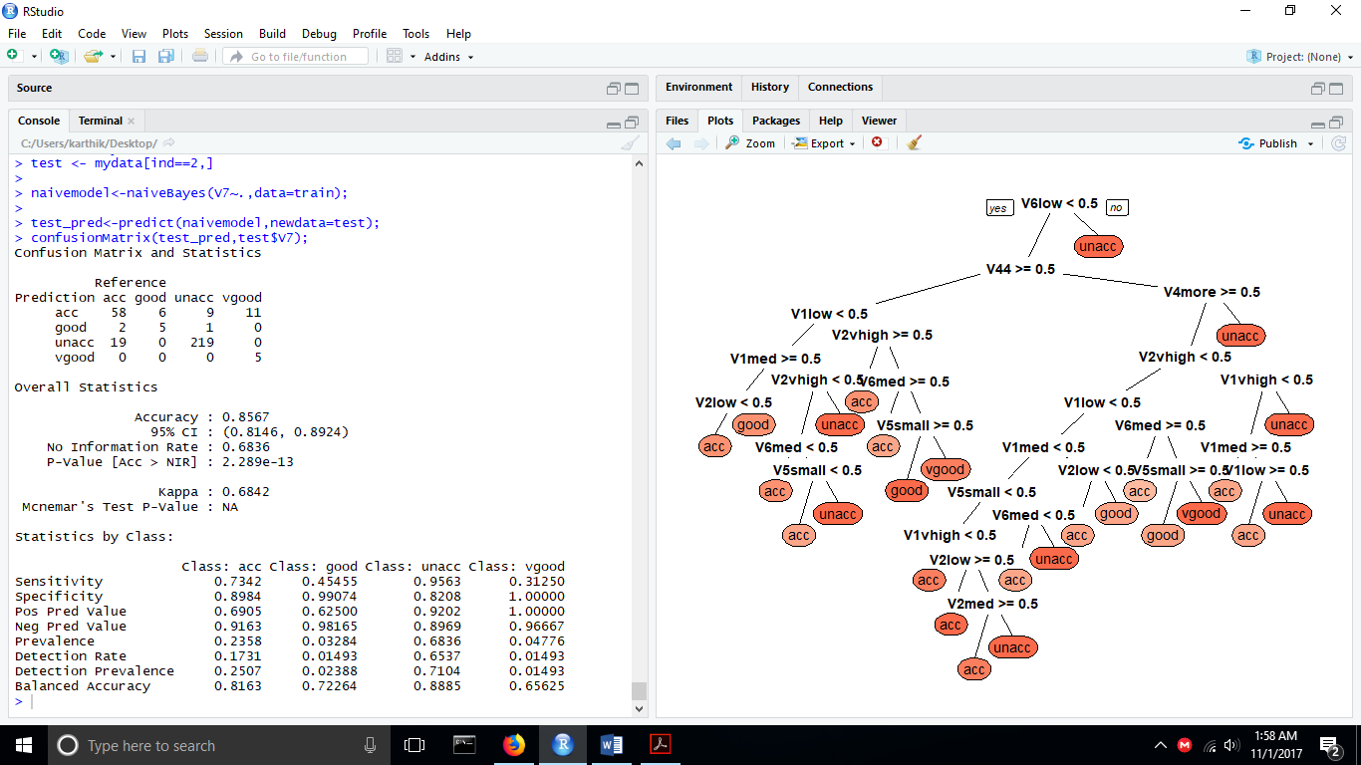

**Accuracy: 85.6%**

**Precision, Recall and f- measure**

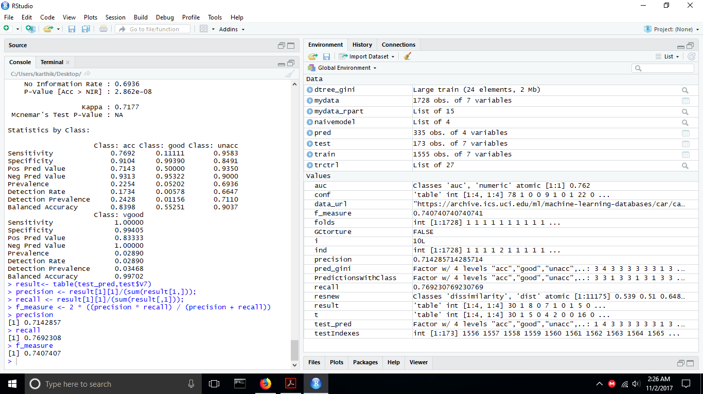

**Using 10 fold cross validation similar to 1 a**

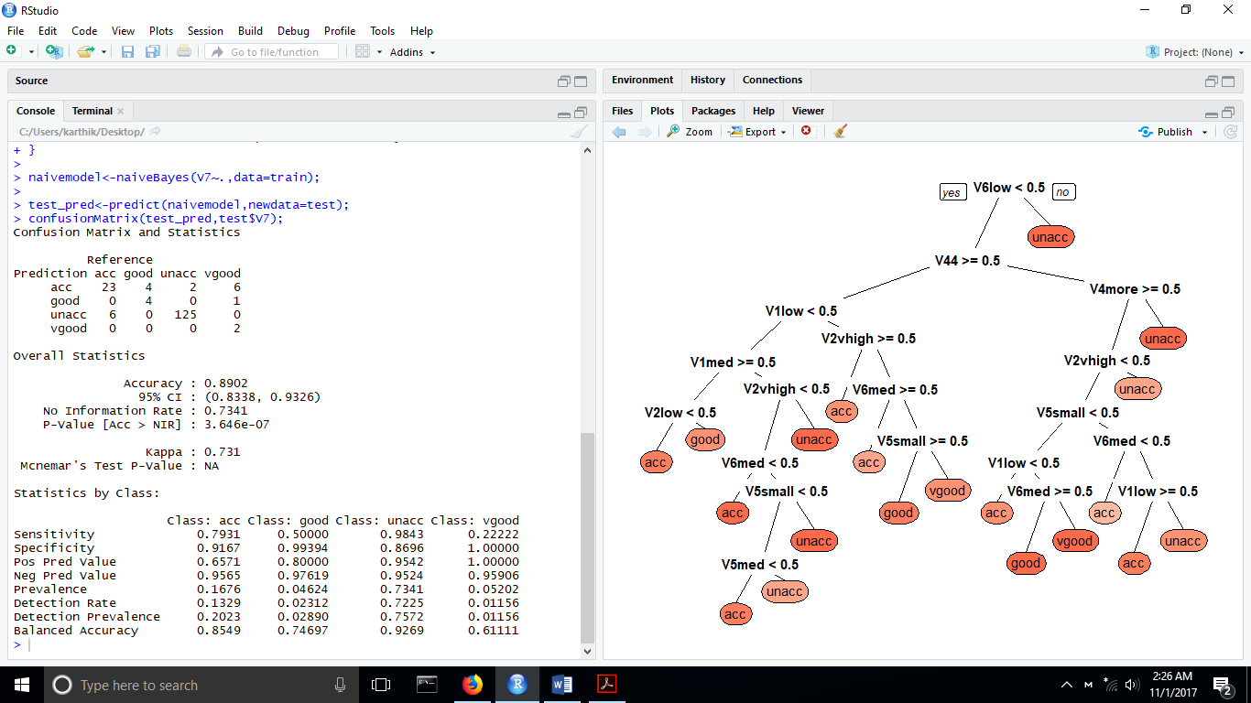

**Accuracy now : 89.02%**

**This classifier performs better with case 2 i.e 10 fold cross validation**

**ROC Curve**

**pred<- predict(naivemodel,test,type='raw')**

**auc<-auc(test$V7,pred[,2])**

**plot(roc(test$V7,pred[,2]))**

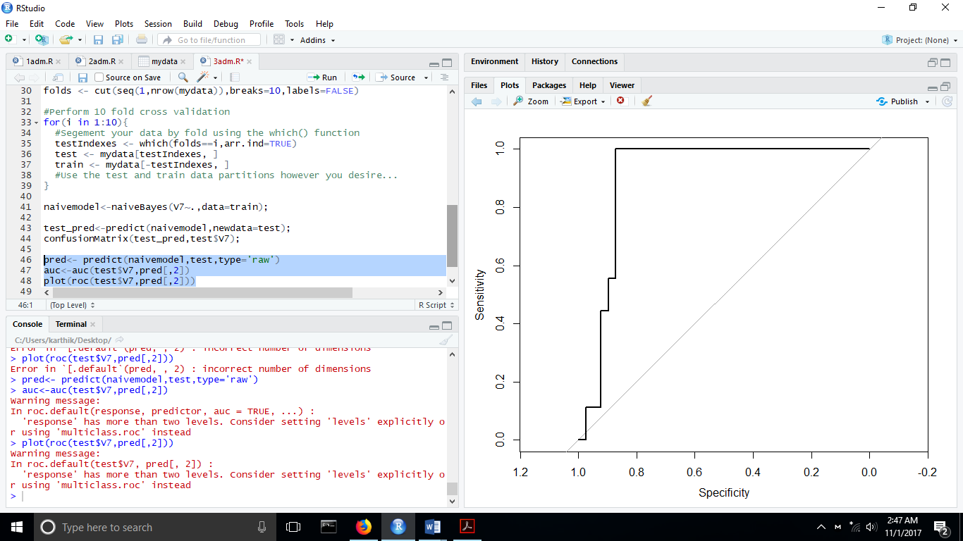

**Area under the curve: 0.9031**

**1.d Artificial Neural Network – with and without hidden layers**

**A change in dataset as artificial neural network requires numerical data to compute weights;**

Dataset-url: <https://www.kaggle.com/uciml/breast-cancer-wisconsin-data/data>

Include the library neuralnet

**Neural Network with two hidden layer:**

a=neuralnet(formula=result~radius_mean+texture_mean+perimeter_mean+area_mean+smoothness_mean+concavity_mean,data=train,hidden=2)

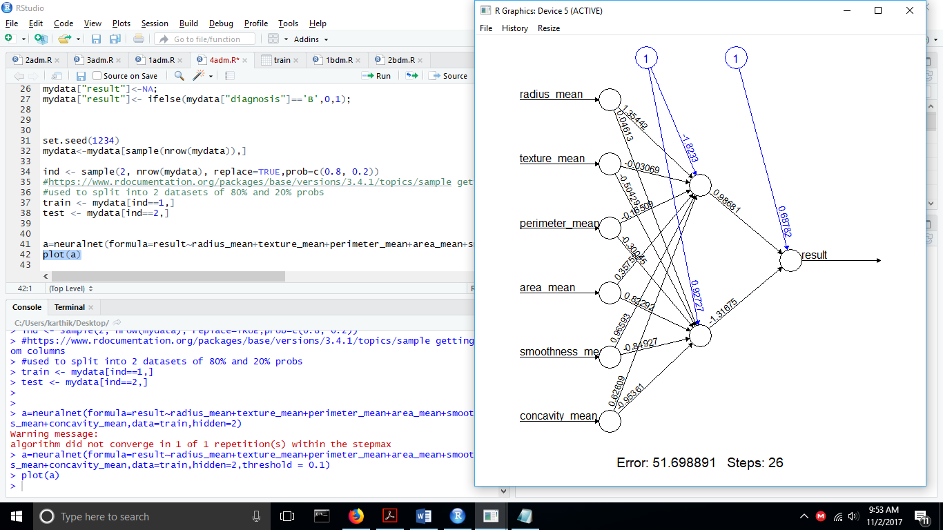

**Neural Network with no hidden layer:**

a=neuralnet(formula=result~radius_mean+texture_mean+perimeter_mean+area_mean+smoothness_mean+concavity_mean,data=train,hidden=0,threshold = 0.1)

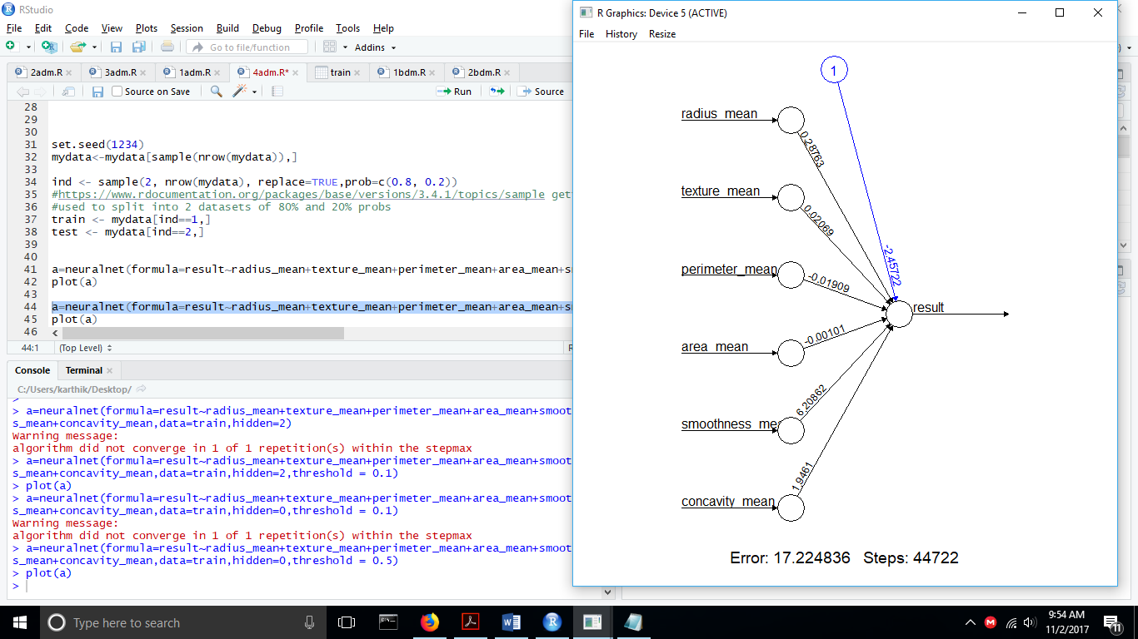

**10 fold cross validation**

**Neural Network with two hidden layer:**

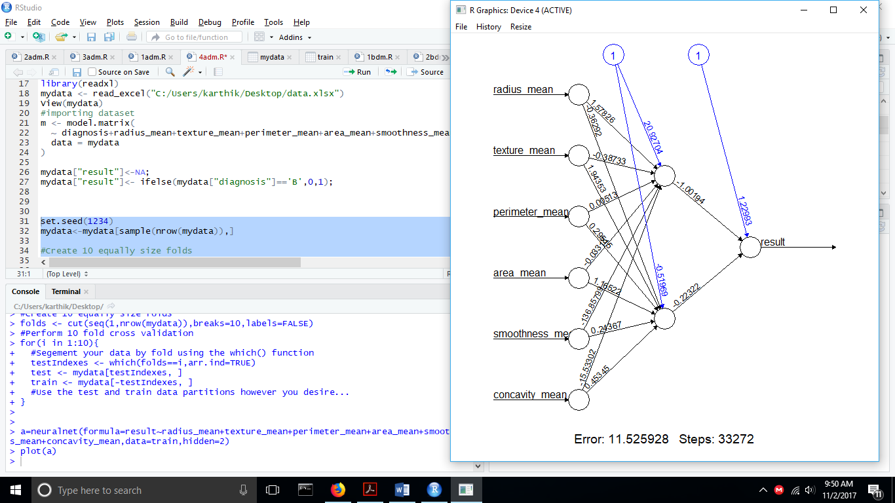

**Neural Network with no hidden layer:**

